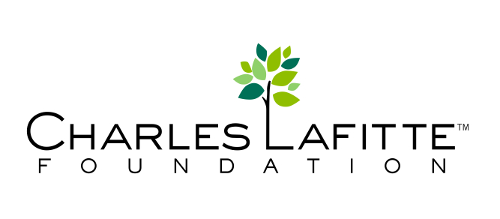

MONTH ##, 2015
Dear [PERSON/ORGANIZATION],
I am running a book drive to collect new and used books for kids and teens in your area and have chosen you to be the beneficiary of the books that are collected. The Champions of Change book drive is a program is sponsored by the Charles Lafitte Foundation. I am hoping you will partner with CLF and me to help other kids have better access to books.
[WRITE A COUPLE OF SENTENCES ABOUT YOURSELF HERE]
The Charles Lafitte Foundation’s Kids Corner has collected over 15,000 books for underserved kids through annual book drives and would like to continue to increase that number. The Charles Lafitte Foundation believes in the power of the individual and how one person can inspire a group and then a community to realize even greater goals. They believe that inspiration is often best shared by a child.
I am so excited to collect books for your organization and will keep you updated throughout the process. Please let me know how to sort the books and any other needs you have. For more information about the Champions of Change Program, please visit www.charleslafitte.org. If for any reason you organization would not like to be part of this process please contact me immediately.
Sincerely,

NAME

CONTACT INFORMATION

