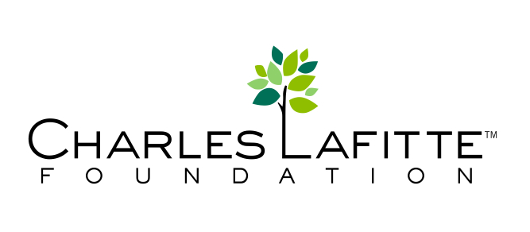

MONTH XX, 2015
Dear [Collection Place]:
Thank you so much for your generously allowing me to collect books at [Organization Name]. Together, we raised [NUMBER OF BOOKS] books for local kids and teens that will be happy to receive them. The books will be going to [NON PROFIT BENEFICIARY], where they will distribute them to the kids they serve.
Thank you again, and we look forward to your continued support.
Sincerely,
NAME

CONTACT INFORMATION

